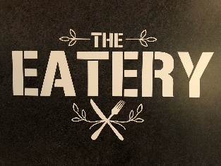
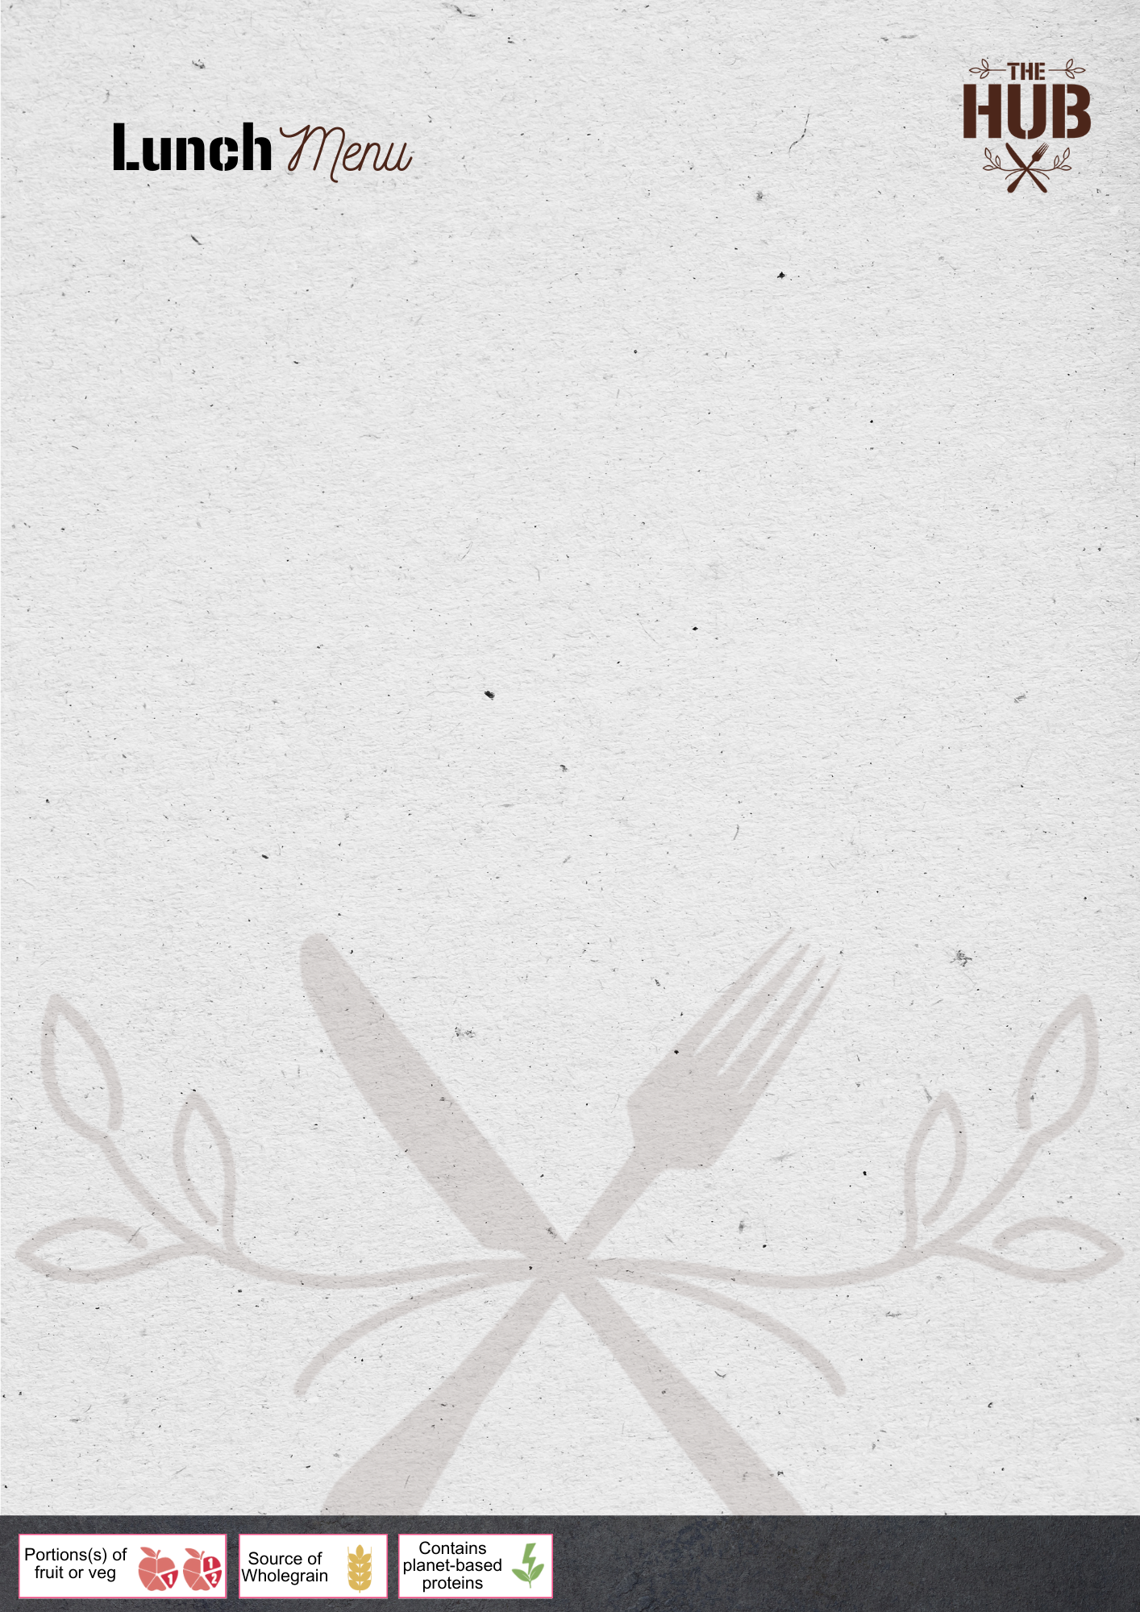

WEEK ONE – AUTUMN WINTER

 | Green Earth Monday | Tuesday | Wednesday | Thursday | Friday
 | Homemade Macaroni Cheese, served with Crispy Fried Onions  (V) | Chicken Tikka Masala Curry served with Rice | Roast of the Day, Roast Potatoes & Gravy | Pork Sausages, Mashed Potatoes & Gravy | Sustainably Sourced Battered Fish & Chips
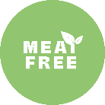 | Mexican Bean & Roasted Vegetable Burrito  (V) | Cheese & Tomato Pizza served with Garlic Bread  (V) | Veggie Sausage Casserole served with Yorkshire Pudding  (V) | Veggie Bolognese served with Pasta  (Ve) | Cheese & Onion Pastry Roll, served with Chips  (V)
 | Homemade Pasta Pot of the Day | Homemade Wrap of the Day | Cajun Dirty Rice  (Ve) | Jumbo Hotdog, with crispy onions | Popcorn Chicken & Chips
 | A selection of Hot Paninis including Ham & Cheese, Pepperoni & Cheese, Cheese & Beans, Just Cheese
Available Daily:
Jacket Potatoes with a choice of Beans, Cheese or Tuna Mayonnaise
A selection of Sandwiches and Baguettes

 | Main Meals served with a choice of Vegetables including Beans
A selection of cookies, cakes & traybakes available daily
Fruit
Yoghurt

WEEK TWO – AUTUMN WINTER

 | Green Earth Monday | Tuesday | Wednesday | Thursday | Friday
 | Cheese & Tomato Pizza served with Garlic Bread  (V) | Classic Beef Bolognese served with Pasta | Roast of the Day, Roast Potatoes & Gravy | Chicken Pie, served with Mashed Potatoes & Gravy | Sustainably Sourced Battered Fish & Chips
 | Loaded Cheesy Bean Hot Pitta Parcels  (V) | Plant Based Veggie Meatballs, Tomato Sauce & Pasta  (Ve) | Quorn Sausage Toad in the Hole served with Roast Potatoes & Gravy  (V) | Homemade Macaroni Cheese, served with Crispy Fried Onions  (V) | Cheese & Onion Pastry Roll, served with Chips  (V)
 | Homemade Pasta Pot of the Day | Homemade Wrap of the Day | Homemade Pasta Pot of the Day | Homemade Wrap of the Day | Popcorn Chicken & Chips
 | A selection of Hot Paninis including Ham & Cheese, Pepperoni & Cheese, Cheese & Beans, Just Cheese
Available Daily:
Jacket Potatoes with a choice of Beans, Cheese or Tuna Mayonnaise
A selection of Sandwiches and Baguettes

 | Main Meals served with a choice of Vegetables including Beans
A selection of cookies, cakes & traybakes available daily
Fruit
Yoghurt

WEEK THREE – AUTUMN WINTER

 | Green Earth Monday | Tuesday | Wednesday | Thursday | Friday
 | Homemade Macaroni Cheese served with Crispy Fried Onions  (V) | Smokey Barbeque Chicken & Sweetcorn Meatballs served with Rice | Roast of the Day, served with Roast Potatoes & Gravy | Classic Chilli Con Carne, served with Rice | Sustainably Sourced Battered Fish & Chips
 | Quorn Sausage & Bean Loaded Hot Pockets  (V) | Plant Based Cottage Pie, served with Gravy  (Ve) | Quorn Sausage, Roast Potatoes & Gravy  (V) | Cheese & Tomato Pizza served with Garlic Bread  (V) | Cheese & Onion Pastry Roll, served with Chips  (V)
 | Homemade Pasta Pot of the Day | Homemade Wrap of the Day | Cajun Dirty Rice  (Ve) | Jumbo Veggie Hotdog with crispy onions | Popcorn Chicken & Chips
 | A selection of Hot Paninis including Ham & Cheese, Pepperoni & Cheese, Cheese & Beans, Just Cheese
Available Daily:
Jacket Potatoes with a choice of Beans, Cheese or Tuna Mayonnaise
A selection of Sandwiches and Baguettes

 | Main Meals served with a choice of Vegetables including Beans
A selection of cookies, cakes & traybakes available daily
Fruit
Yoghurt

